**Assignment 5 (OOPs)**

**Name: Yatin Kanwar   
Branch: ECE  
SID: 23105057**

**Q1. Write a C++ Program the use of the static member functions, in checking the number of objects created for a class.**

#include <iostream>

using namespace std;

class MyClass {

private:

    static int objectCount;

public:

    MyClass() {

        objectCount++;

    }

    ~MyClass() {

        objectCount--;

    }

    static int getObjectCount() {

        return objectCount;

    }

};

int MyClass::objectCount = 0;

int main() {

    MyClass obj1, obj2;

    cout << "Number of objects: " << MyClass::getObjectCount() << endl;

    {

        MyClass obj3;

        cout << "Number of objects: " << MyClass::getObjectCount() << endl;

    }

    cout << "Number of objects: " << MyClass::getObjectCount() << endl;

    return 0;

}

**Output:  
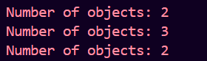**

**Q2. Write a C++ Program that inputs today’s date:mm/dd/yy and determines and prints tomorrow date correctly. Choose appropriate class declaration and its member data and functions.**

#include <iostream>

#include <iomanip>

using namespace std;

class Date {

private:

    int day, month, year;

public:

    Date(int d, int m, int y){

        day=d;

        month=m;

        year=y;

    }

    void incrementDay() {

        static int const daysInMonth[12] = {31, 28, 31, 30, 31, 30, 31, 31, 30, 31, 30, 31};

        day++;

        if (day > daysInMonth[month - 1]) {

            day = 1;

            month++;

            if (month > 12) {

                month = 1;

                year++;

            }

        }

    }

    void printDate() const {

        cout <<month << "/"<< day << "/"<< year << endl;

    }

};

int main() {

    int d, m, y;

    cout << "Enter today's date (mm/dd/yy): ";

    char slash;

    cin >> m >> slash >> d >> slash >> y;

    Date today(d, m, y);

    cout << "Today's date is: ";

    today.printDate();

    today.incrementDay();

    cout << "Tomorrow's date is: ";

    today.printDate();

    return 0;

}

**Output:**

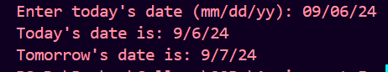

**Q3. Write a C++ Program to read any five real numbers and print average using a static member class use parameterize constructor for entering the numbers.**

#include <iostream>

using namespace std;

class NumberStats {

private:

    static int numbers[5];

public:

    NumberStats(int num, int index) {

        numbers[index]=num;

    }

    static double getAverage() {

        double sum=0;

        for (int i = 0; i < 5; ++i) {

            sum += numbers[i];

        }

        return sum/5;

    }

};

int NumberStats::numbers[5] = {0};

int main() {

    int arr[5]={5, 6, 7, 7, 7};

    for (int i = 0; i < 5; ++i) {

        NumberStats stat(arr[i], i);

    }

    cout << "Average of entered numbers: " << NumberStats::getAverage() << endl;

    return 0;

}

**Output:**

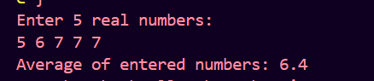

**Q4. Write a C++ Program ,To demonstrate the use of Parameterized and copy constructors.**

#include <iostream>

using namespace std;

class MyClass {

private:

    int value;

public:

    MyClass(int v) : value(v) {}

    MyClass(const MyClass &other){

        value=other.value;

        cout << "Copy constructor called" << endl;

    }

    void display() const {

        cout << "Value: " << value << endl;

    }

};

int main() {

    MyClass obj1(10);

    MyClass obj2 = obj1;

    obj1.display();

    obj2.display();

    return 0;

}

**Output:**

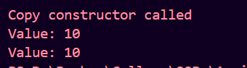

**Q5. Write a C++ Program ,To demonstrate the use of default constructors of employee’s data.**

#include <iostream>

#include <string>

using namespace std;

class Employee {

private:

    string name;

    int id;

public:

    Employee() {

        name = "Unknown";

        id = 0;

    }

    void display() const {

        cout << "Employee Name: " << name << endl;

        cout << "Employee ID: " << id << endl;

    }

};

int main() {

    Employee emp;

    emp.display();

    return 0;

}

**Output:**



**Q6. Write a C++ Program ,To demonstrate the use of This pointer.**

#include <iostream>

using namespace std;

class Box {

private:

    int length;

public:

    Box(int len){

        length=len;

    }

    void display() const {

        cout << "Length: " << *this*->length << endl;

    }

};

int main() {

    Box b1(10), b2(20), b3(15);

    b1.display();

    b2.display();

    b3.display();

    return 0;

}

**Output:**

